Science Publishing DAO Proposal

By Jonathan Kung

**Summary:**

Academic science is currently caught in a viscous cycle of three self-perpetuating crises: affordability, functionality, and replicability[1]. The goal of this Science Publishing DAO is to build out a healthy Global Science Intellectual Commons (GSIC), a common pool resource (CPR) that can address all aforementioned crises in an effective and sustainable manner. This CPR is readable by all, while writable and managed by those who have published a paper. In addition, every bit of information published is available for “eternal review,” a process that compliments peer review by making research subject to continuous formal assessment[2].”

Table of Contents:

Problem 2

Solution 7

**Science Publishing DAO Architecture Outline** 8

**1.** Basics 8

**2.** Governance 8

**3.** Walkthrough Diagrams 10

**4.** Product Strategy (Features) 13

**5.** External Strategy (Interfacing with Non-Academic Institutions) 15

**6.** Technology Development 17

Competitive/Collaborative Decentralized Science (DeSci) Landscape 21

• Web 3.0 Competition (Non-Comprehensive) 21

• Web 2.0 Knowledge Management/Generation Systems (Non-Comprehensive) 23

Gantt Chart 25

Financials 26

References 26

**Annotated Bibliography** 26

Appendix 30

Appendix A: Sequence Diagram of Academic Publishing Status Quo 30

Appendix B: Traditional vs. Decoupled Peer-Review Models 31

Appendix C: Shows how Government Funding has Shifted Priorities between 2000-2017 32

**Problem:**

**Figure 0**: Basic sketch of the status quo in Academic Publishing post-internet. Publishers have an outsized control of the ecosystem for the value they offer: digital marketing. This has inadvertent negative effects on the efficacy and health of the Scientific Commons.

Big Science Publishing not only owns the journals that disseminate scientific knowledge, but control the workflow of science itself (Figure 1[3]). They manage the reputation system that determines a scientist’s career and impact, as well as the funding potential available to them, and they own the overwhelming majority of scientific copyrights. Any scientist must work within their system – the result of years of labor, passion, and thought – to survive, let alone have any impact.

However, science is meant to be decentralized and distributed. **Decentralization and distribution are not only important on the principle of more people having access to science, but are required for any successful scientific endeavor**. It is no secret that in order to discover findings that are truly universal, findings must be verified and replicated by as many people as possible across geographic, governmental, and institutional lines. A decentralized community of researchers seeking deeper truths is necessary for scientific knowledge to flourish.

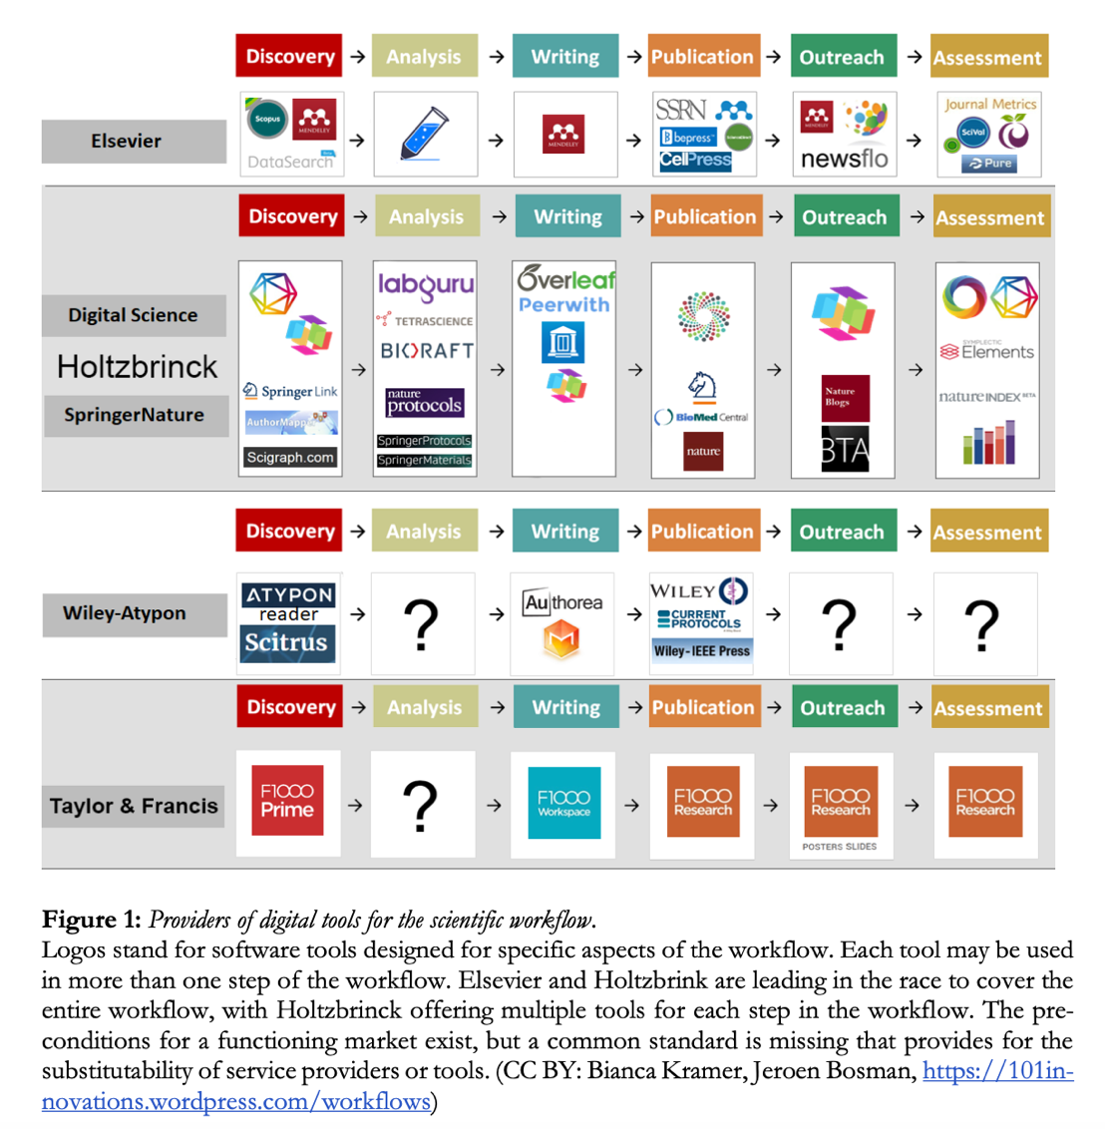

The current system is compromising the scientific method as we know it. This compromise is felt within science: numerous Nobel Laureates and Fields Medalists have used their position to boycott the state of publishing and use of bibliometrics. An example of these boycotts is the Cost of Knowledge[4] protest of Elsevier, the largest for-profit journal in the world, which was initiated in 2012 by Fields Medalist Timothy Gowers of the University of Oxford. Over 80% of the nearly 16,000 signatories pledged not to publish in Elsevier. However, four years after the signing of the Cost of Knowledge, only 38% of the original signatories maintain their commitments to their pledge, an indication of how difficult it is for even established scientists and institutions to reform the system. Despite the difficulties, attempts continue to be made to combat the problems with Big Publishing: in 2019, the entire University of California (UC) system cancelled their subscriptions to Elsevier, followed by MIT, University of North Carolina, and the State University of New York (SUNY) system. This push-and-pull is characteristic of the current landscape. Many scientists and research institutions want reform, but cannot maintain their momentum against the forces of Big Publishing. In the meantime, the quality of research has lowered, public trust in science has faltered, and scientific careers are full of painful moral compromises simply to exist. *In its current state, the primary winners in the ecosystem are the publishers and university administrators.*

The current scientific process is: (See sequence diagram version in Appendix A)

1. A scientist creates a proposal for a grant.
2. If accepted, the proposal funds a project.
3. The scientists then execute the project (conducts experiments, writes the paper).
4. The scientist then submits the paper for publishing.
5. Once in the publisher’s hands, editors either decide to reject it or whether it's worth going through the peer review process.
6. The paper goes through peer review, 2-3x. Peer reviewers give comments and suggestions. The scientist makes adjustments/corrections.
7. The editor makes the decision regarding whether the paper is published.
8. If the editor decides to publish, the scientist pays the publishing company $2-10k to get their work published.
9. All copyright privileges to the document are signed over to the publishing company.
10. The number of times a paper is cited, among other factors, will then contribute to the scientist’s reputation score. Two metrics are key in this calculation:
    1. Impact factor (IF): the ranking of the journal that published the paper.
    2. h-index: the rough average of citations a scientist has received per paper that is meant to be a composite metric for quantity (output), quality, and impact.

The major ways that publishing companies exert a negative influence are:

* Paywalls – restrictions that require payment for access i.e., subscriptions - that prevent access to the papers that Publishers did not produce.
* The Incentive structure created to maintain their “quality” brand is useful from a business perspective but harmful to the scientific ecosystem at large.

The problem with paywalls has been widely recognized and re-spawned[5] the Open Science Movement – which includes the Open Access Movement and Guerilla Open Access Movement. Projects such as ArXiv (preprint journal), PLOS One (major Open Access journal), Allen Institute (privately-owned Open Science Center), and Sci-Hub (pirated access to journals) are examples of non-traditional ways of publishing and accessing knowledge.

**Figure 2**: Redrawn slide from presentation of Ana Persic, Division of Science Policy and Capacity-Building (SC/PCB), UNESCO (France) presentation to Open Science Conference 2021, ZBW — Leibniz Information Centre for Economics, Germany[6].

Governments around the globe have also been funding Open Access programs such as [SPARC](https://sparcopen.org/our-work/us-national-open-access-policy/), [MIT’s Center for Collective Intelligence (MITCCI)](https://cci.mit.edu/), [Center for Open Science (COS)](https://www.cos.io/?hsLang=en), [Open Research Europe (ORE)](https://open-research-europe.ec.europa.eu/), [Research Center for Open Science and Data Platform (RCOS)](https://rcos.nii.ac.jp/en/) etc. The US’s Federal Research Public Access Act of 2006 required any US Federal Government Agency with a research budget greater than $100M to create an open access repository – this applies to 11 US agencies including NASA, EPA etc. With greater and greater frequency, universities are mandating their researchers to exclusively publish in Open Access Journals, some of which are government funded. These initiatives incite pushback from the commercial sector, including the instantiation of policies like SOPA, PROTECT IP Act, and Research Works Act, while evading the “Open Access” political barrage by using their brands to create high-profit and profile Open Access Journals.

ORE was started and continues to be funded by the European Commission (EC). On behalf of ORE, the EC contractually pays F1000, a publisher, a flat fee of 780 EUR/paper to market ORE published papers on F1000’s platform. Usually, publishing in Open Access Journals costs $10+k/paper[7]. This focus on **Open Science/Access, though romantic, has from a macro perspective inadvertently hurt not-for-profit Professional Societies and shifted the costs from the readers to the authors.**

Since the invention of decentralized autonomous organizations (DAO) in 2016, there have been several attempts to address the problems of Open Science. A project called Open Access DAO recently launched (11/2021), with the goal of crowdsourcing funds to buy journals to quickly make their contents open-access. Most of these blockchain-based solutions address the paper access issue, but ***very rarely do any of the current projects address the governance or the reputation infrastructure of academic science***. These neglected issues are arguably more responsible for the state of science today. Previous attempts to change the reputation and governance metrics via gamification have failed (see Competitive/Collaborative DeSci Landscape section).

Thus far, the pirating site Sci-Hub (launched 2011) from the Guerilla Open Access Movement has been the most effective tool for the Open Science Movement[8]. Sci-Hub is heavily used by scientific communities in developing countries like China, India, Iran, Kazakhstan etc. to bypass the untenable paywalls. Elsevier, American Chemical Society, and Wiley etc. all have lawsuits against Sci-Hub and have gotten the site blocked in many countries including the US and many Western countries since 2015. However, as long as one country maintains the site, everybody with a WiFi connection can access and its repository – made easier with VPN technology. In 2016, Sci-Hub founder Alexandra Elbakyan was listed #6 on the “Nature’s 10” – Springer Nature’s annual list of ten “people who mattered” in science. **The most effective solution for the Open Access Movement so far is an illegal one; we must do better.**

In the highly competitive world of academic research, scientists are forced to play the publisher’s game to survive as scientists. The h-index[9] and impact factor (IF)[10] of the journals are key elements of a scientist’s CV. The result is that **researchers learn to game metrics by maximizing citations by getting published in major journals. This in turn has led to collusion: situations where, for instance, professors agree to cite each other’s papers as much as possible (citation rings), p-hacking[11], paper mills, etc.**

Bibliometrics is the field of metrics used for analysis of publications and their properties. In science, it is a discipline in and of itself. Neither IF nor the h-index are respected metrics by the bibliometric community and, at this point, most of the scientific community; yet these “invalid indicators” continue to be used. In the present moment, university presidents and managers are generally more concerned about “branding” and the endless search for funding than adhering to academic principles and values. Attracting students and making money are no small tasks. ***But keeping up with the rhetoric surrounding the globalization of the university market has kept administrators (non-scientists) busy and generally less attentive to the nuances of the metrics used to evaluate and hire their STEM professors***. **Administrators are using the culture’s current obsession with rankings and reductive composite single figures – simple for prospective students to digest – to direct the perceived meaning of these invalid indicators to a preferred narrative.** However, though bureaucrats maintain some blame, the proliferation of the h-index has largely been a grassroots phenomenon. A deeper psychosocial analysis involves looking at the reasons why the prestige economy is perpetuated by scientists themselves, and providing the right tools to replace it.

Work published in high end journals like Nature favor “illuminating, unexpected, surprising” positive results, as they state outright in their submission requirements[12]. **The decentralized and distributed nature of science suffers when it depends on this unfortunate yet understandable for-profit, centralized, marketing-focused, news-media internet business model.** Data and interpretation-sharing amongst scientists is essential for scientific work, for education, and for the democratization of the knowledge. *However, “illuminating, unexpected, surprising” positive results only account for a very small percentage of useable research.* Most hypotheses tested in research will have negative results, or will start with single observations. At present, these only account for ~10% of all published works. A narrative can be constructed only after a string of research has been completed. However, to get published, the story must be “big enough.” **In order to get published, scientists will sit on research for years even after it is complete, spending their time crafting an exciting narrative; or, they oversell the significance of their research.** We might be familiar with such narratives from clickbait articles such as “Studies show chocolate can help you lose weight,” but the problem affects all the scientific disciplines, even harder sciences such as physics.

This hyperfocus on purely validated, positive results is a serious problem with the current publishing system: single observation papers, negative results papers, and replication papers are not profitable but provide important context, – not attention grabbing and hard manage publication volume with current “quality” standards. Single observation studies are much more easily checked and distributable. Negative results provide important contextual information about a body of work. These two types of research are essential players in the scientific research ecosystem, but they are effectively being discouraged by the nature of the system. **By using a reputation structure that incentivizes these types of research, the Scientific Publishing DAO will provide avenues for affordability, functionality, and replicability, improving public trust in scientific research and the health of falsifiable disciplines in general.**

**Solution:**

**The break of the vicious cycle of science publishing will not be technological, but with governance. The proposed solution is to build a decentralized, nonprofit, online blockchain-based model for academic publishing that circulates and shares knowledge widely. This model will allow researchers to gain prestige among their peers based on the merits of their research rather than journal brand association.**

**The goal can be accomplished through MVPR[13] with enhancements to the citation structures – i.e., annotated citations, variegated citation frameworks, non-referential citations. This will look like a digital intellectual “agora[14]” with a built-in value capture system. The value capture system builds out an easily searchable reputation infrastructure and Open Access knowledge repository system, which will transcend other projects by folding-in existing systems. Simply stated, Science Publishing DAO is an advanced bibliometric and paper storage system elegantly managed by the advanced decentralized governance of MVPR to instantiate an Open Science platform with built-in healthy and sustainable reputation infrastructure.**

Actors in the system earn/lose reputation tokens based on their contributions to the ecosystem by validating work, producing new knowledge, and participating in votes. A base citation structure can be built using the free information online (authors, title, work cited, abstract etc.) so that the reputation of *all* scientists – whether they are using the ecosystem or not – can be calculated as a new bibliometric. However, authors who publish new work on the DAO will have more tools available to share and interact with their community. To contextualize and fairly evaluate research, members must include certain types of information to assist with any individual paper's long-term processing. This may include but is not limited to: a unique citation form, listing out tags, and a list of 20 qualified-peer-reviewers – with no notable conflict of interest or bias, i.e., same university department, previous collaborators, etc. Note that the whole system promotes crowdsourcing, which further enhances scalability.

When a paper is submitted, the platform will process the paper and add the paper to the WDAG citation structure, which results in the minting of reputation. This will get posted as “recent work” in its category on the ad-less webpage. Marketing is important, but the usual method of posting scientific work on a webpage with an opinion article is trivial, as is most of the social media coverage and email updates around conferences. The loudest and the most popular research – not necessarily the best - generally dominates the conversation.

All research publication systems will involve some measure of curation, but other methods of curation can use more useful categorical frameworks and allow for more nuanced dissemination of information. In this system, published papers that are not being cited will be networked with other papers, using novel algorithms, to potentially find unexplored connections over time. The paper's potential associations can be listed on the website until a member of the ecosystem can recognize its utility. Additionally, a paper can be cited both individually and in context. As a paper persists in the ecosystem, it will accumulate citations, peer-reviews, and potentially replications. Peers will rate the work with validation methods such as citation, peer-views, replications, and comments, all of which require reputation staking.

Any work published on the DAO platform belongs to the platform but can be read by anybody in the world. Over time the positive and negative citations will accumulate, as well as peer-reviews and possible replications. Papers will better capture and value what a researcher has done, as well as what they can do as opposed to just evaluating the quality of a researcher based on the number of papers that mention a scientist’s name and how many times that name was cited (h-index).

Now that we have a reputation system that can be sustainably decentralized, this would be a viable replacement for the legacy system and solve the reputation problems often found in Academic Publishing’s centralized organizations.

**Science Publishing DAO Architecture Outline:**

1. Basics**:**
   1. **Multi-Coin System**:
      1. **Low Velocity** NFT Reputation tokens as the basis for fungible work tokens.
      2. **High Velocity** Stable coins/funding tokens: Casper for now, stable coins in the future.
   2. **Multiple Ecosystem Actors**: Peer-Reviewers, Replicators, Authors, Questioners, Editors, Indexers, Curators.
   3. **NFT Knowledge Assets**: Both the paper and its published data sets are NFTs.
   4. **IP-NFT’s** to better interface with funding agencies and Industry.
2. Governance**:**

The Science Publishing DAO will adopt a similar role that the ETA plays in the DEVxDAO ecosystem. SubDAO’s will generally be journals, professional societies, departments, or individual scientists.

* 1. **MVPR Parameters:** 
     1. **Seasonal Governance**: Increases dynamicity and decreases the capacity for a system to be gamed[15]. Mathematically sweeping between at a voted pace/random governance structure. No one can see what the numbers are, so it is impossible to game the system. i.e., default C11 = ½. Instead, it could be sweeping or randomly flickering between ½ and ‘n.’
        1. **In the case of Science Publishing there could be replication seasons** where the replication bounties on published works will increase in response to the state of the field or on a (semi)annual basis or based on a Predator-Prey relationship with “innovation.”
     2. **Validation Pool:**
        1. Stage 1-5 suggestions (Calcaterra, 2018)[16],[17].
     3. **WDAG:** 
        1. Preferred mature ecosystem parameters (Stage 5).
           1. Initial Value: Depends on starting point: ARTiFACT, preprint journal, or ready for peer-review. Each level has a graduated value increase in reputation minted, respectively.
           2. Revaluation: q2 = 1-1.1
           3. Limit to the length of reference chain effect: q3 = Inf
           4. Leaching Value: will vary depending on sanction and phase.
           5. Limit of References: Managed by ranked annotated bibliography.
           6. Limit of Referrers: Managed by ranked annotated bibliography.
           7. Limit Potency: Replication bounties and aging peer-review. q7 will be a negative linear function with time.
     4. **Reputation NFT's Rough Valuation:**

Flat rate reputation is minted for knowledge validation and addition. Papers can acquire or lose more reputation based on the impact of the papers contributions. Reputation minting is hyper-inflationary, making system takeovers i.e., 51% attacks improbable for any individual or group.

* + - 1. Co-Authorship Reputation Distribution:
         1. MVPR voted reputation NFT distribution amongst co-authors.
      2. Validation:
         1. Citation < Peer-Review < Replication
         2. Traditional Citations < < Annotated Citations
         3. Papers - and thus authors - can gain or lose reputation based on community evaluation and interaction.
      3. Publishing New Work:
         1. Single Observations:

Negative Results < Positive Results

* + - * 1. Multithreaded:

Negative Results < Positive Results

* + - * 1. Single Observation < Multithreaded

This is because multithreaded works are a denser combination of positive, negative, and single observations.

* + - * 1. Replication that becomes new work > Single Observation
      1. Validation < Publishing New Work
         1. Sometimes Replication bounties will increase based on Professional Society DAO needs to incentivize a focus on validation over innovation.

1. Walkthrough Diagrams**:**

**Figure 3**: Model of the semipermeable inclusion exclusion criteria of scientific knowledge. Figure 5 below summarizes some of the states that are allowed into the ecosystem. Figure 6 below summarizes how retraction cases are handled.

**Figure 4**: Higher resolution diagram of how the system would work.

Science Publishing DAO will be publishing papers under [CC BY license](https://creativecommons.org/licenses/by/4.0/). Its associated data will be published using the Creative Commons Public Domain Dedication ([CC0 license](https://creativecommons.org/publicdomain/zero/1.0/)) as endorsed by [FAIR Data Principles](https://doi.org/10.1038/sdata.2016.18).

**Figure 5**: There are a plethora of different states that papers can enter the Science Publishing DAO ecosystem. This figure demonstrates the difference between traditional publication, preprint publication, and non-traditional peer-review. The bottom right figure shows how a paper’s reputation will be calculated and will continue to accumulate reputation. Publishing directly through the DAO allows for more access to the unique toolset the platform offers.

**Figure 6**: This figure outlines some of the ways that papers can be retracted, but not deleted in the system. The blemishes of history can be just as impactful/informative as the positive results. The top figure shows that if a paper has 3x replications, only 2+ negative reviews will automatically be flagged, and its fate will be decided by its associated Professional Society DAO. The bottom figure showcases that 1) a retracted paper can be cited and 2) if an annotated citation is retracted the paper citing can be indirectly flagged for a retraction resolution by the associated Professional Society DAO. Not deleting all retracted papers from the system addresses the “riffability” of ideas.

1. Product Strategy (Features)**:**
   1. **Publishing Breadth:**
      1. For papers that already exist, reputation can be assigned to anybody that has a name in a paper. **Moving forward, scientists are encouraged to submit their papers and associated data in the form of negative/positive results, single observations, and replication studies.** This will dramatically increase the publication volume[18]. With this increase in volume, Scientists will have a lot more technical and governance tools, ownership of the platform to aggregate, share, collaborate, give/receive feedback than before.
   2. **Founders Sprint[19]:** 
      1. The DAO launch suggestions from the Semada Paper: See Governance Section above.
      2. **DAO founders need better on-off ramp strategies**. The Founder's Sprint is an attempt to create both generalized and specific solutions for DAO founders to effectively build the DAO and decentralize the platform upon launch. An example for this would be a scientist who drops out of academia to start a Science Publishing DAO, but would have considerable difficulty re-entering the science ecosystem.
   3. **Eternal Review:** 
      1. **Replication bounties on highly cited papers**. The more a paper gets cited, the more reputation it will accrue. Replicators can stake work tokens to replicate the experiment and get rewarded with reputation when they have done their job. They get rewarded for confirming but get an extra reward (though not significantly more) if they find a false positive/negative. The work can be crowdfunded. For every false positive/negative, it takes a 75+% irreplicability rate or false positive rate, to make a status change.
      2. **Papers can be updated:** After publishing, papers are usually static. As a person learns, their memories are self-reviewed and updated; they can more easily move forward. Papers, in this system, can serve the same function. Updating a paper creates a new block on the blockchain[20].
      3. **Peer-Review Bounties:**
         1. **Aging paper peer-review:** If a paper has been around for a while (i.e., 10+years), there has likely been many findings. The older papers are going to be a key part of papers currently being written, and a pro-rated peer review can happen to earn reputation tokens or work tokens. This would be added to the chain so that newer onlookers will see more current peer-reviews. This may help incentivize recirculation, validation, and recontextualization of papers that may have served a false narrative or was overlooked, as well as close reading by researchers.
   4. **Historical Context:**
      1. **Ranked Annotated Bibliographies:**
         1. **Will be useful for all who will review** a scientist's work in the future. Whether they are fresh graduate students, peer-reviewers, or funding agencies, having an annotated bibliography will clearly show how the cited works affected influenced the work.
         2. **The annotated bibliographies upon publishing will be immediately readable by the people cited** so it is easy for a scientist to see how people in the community are interpreting their work on its own merits. This can lead to paper updates and FAQ answers as well. Using this input would be extremely useful for novice and seasoned scientists alike.
         3. Annotated bibliographies would also **gracefully address the citation Sybill Attacks** that have been plaguing academic science.
         4. **The citations you do not annotate will be considered a much weaker citation.**
      2. **Ranked Contributions:**
         1. Each author is assigned a percentage for their contributions determined by the co-authors of the paper via MVPR.
      3. **Citations:**
         1. **Citation as a mild form of reputation staking** could increase or decrease your own reputation. This would discourage massive citation dumps.
         2. **Experiment with New Citation Structures**:
            1. Papers are organized by relevant concept chains as well as of order of appearance[21]. This way it is much easier to find and compare historical context across papers. This is a means to experiment with historiography.

**Figure 7:** illustrates an example of a citation framework that better communicates the historical context of the ideas used to generate/formulate the novel ideas presented. Figure 2 uses Bitcoin as an example.

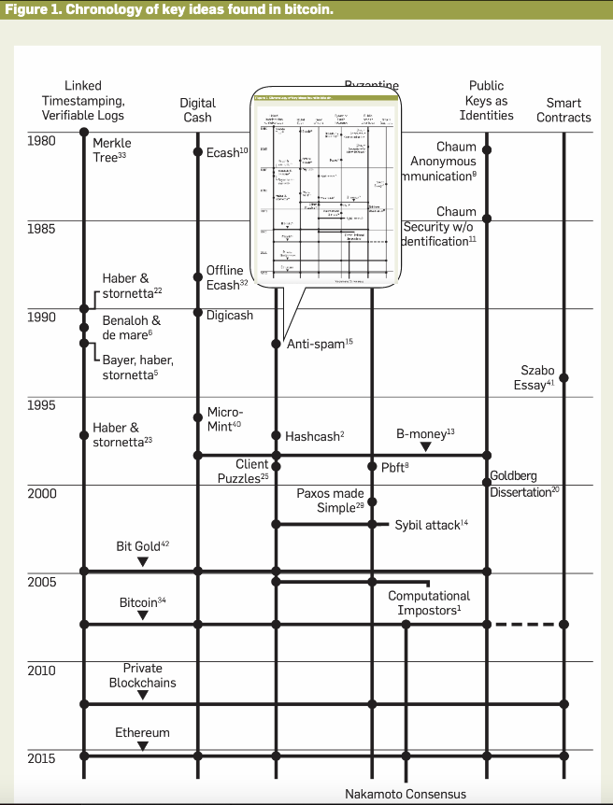

* 1. **Interactiveness**:
     1. **FAQs for published papers**.
        1. Anybody can post a question for free. Questions asked will be listed off-chain, answered questions will be on-chain. The author will not be obligated to answer questions but could save time from having to answer the same questions repeatedly.

1. External Strategy (Interfacing with Non-Academic Institutions)**:**

Government funding is mainly responsible for funding basic scientific research, but industry heavily funds the applied sciences. Industry buys up as much IP as is useful for product and market positioning, in the form of data and patents (see Figure 3 below). University Tech Transfer Offices generally make little money from licensing these patents to industry clients, with the exception of a handful of extraordinary situations. (For instance, the drug marketization of Remicade made NYU ~$1Billion[22].) Converting academic discoveries to products is often called the “Valley of Death”: many promising ideas are extinguished in this process. Of course, not every idea can, or should, survive this process. However, too many ideas with great potential are lost, and this reflects a big gap in development funding. The interface between academic science and industry needs to be explored.

In the DAO, money earned from patent licensing will payout universities and reward the most responsible scientists with reputation, which will trickle into the ecosystem via the WDAG reputation staking citation structure and will fund a Science Treasury DAO. This Treasury DAO will be managed by all scientists, who can use their reputation to decide which scientists or projects should be funded. The Treasury DAO can also be used as a mechanism for a mass payout to members in the ecosystem. Bridging the “Valley of Death” between Academia and Industry with advanced funding mechanisms while maintaining a reputation focused science ecosystem would be a win-win scenario.

* 1. **Ecosystem launch:** 
     1. DAOs are divided and when launched, are surrounded by centralized entities on all sides. An ecosystem launch would be a coalition of DAOs that would launch simultaneously to increase survival in the form of focused on their ecosystem with increased adoption. Also, Academia will have to deal with Industry and centralized Government departments i.e. Department of Defense or Department of Energy etc.
        1. **IP-NFT's Framework:**
           1. A concept developed by Molecule GmbH, IP-NFT’s are a useful interface with Industry. Though the paper to patent process is separate from Scientific Publishing DAO, it should be noted that DAOs that want to focus more on commercialization exist, i.e.,VitaDAO (see description under Competitive/Collaborative DeSci Landscape 2021). Since most of the funding of scientific research is funded by big business as shown in Figure 8 below. VitaDAO is trying to overcome the “Valley of Death” in the drug industry where it needs different funding strategies that the normal grants and patent licensing through University TTOs do not cover.
        2. **Create a suite of industry facing frameworks:**
           1. These frameworks are meant to both improve the interface, get research funded, get scientists more recognition (usually forgotten) without further adopting market protocols within the ecosystem. This interface with industry will send some fraction of the IP exchange to the Science Publishing DAO Treasury where the ecosystem can vote on what to do with the money.

**Figure 8**: U.S R&D performance and funding, by type of R&D and sector: 2017 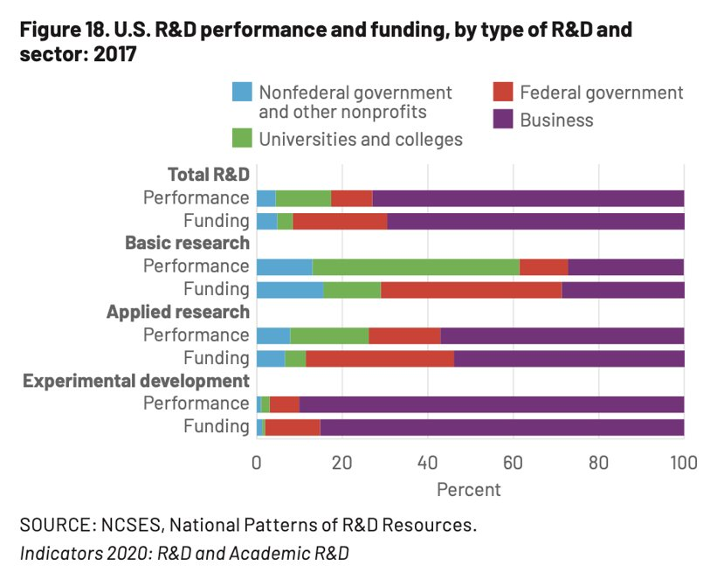

* + - 1. **Policy DAO:**
         1. Needed to help DAO’s on all levels to formalize policies for inner and outer DAO interfacing. Depending on the context, a Policy DAO could also be considered a “Peer” DAO, a sub-DAO or a Governance DAO.
      2. **“Peer” DAO’s:**
         1. **Science Funding DAO:**

Innovations in Science funding needs to be made available. There are ideas about treating research funding as art to attract the high net worth individuals who invest in art. They would get an NFT receipt for their funding contributions that could be worth a lot in the future if the evolution of the ideas are impactful.

Opscientia DAO and VitaDAO are using the Ocean Protocol – data AMM – to create a data/knowledge market that researchers or professional societies could use to interface with Industry. However, further neoliberalization of Academia is dangerous and should be explored carefully.

* + - * 1. **Social Networking DAO:**

**Twitter** is the most used social media platform for academics. The short character limit and general culture of contention leaves much to be desired.

**Medium:** Longer form messaging website created by Twitter co-founder.

**Research Gate:** Research paper Facebook.

**ARTiFACTS**: Public versioning and manuscription of ideas managed by blockchain (see Competitive/Collaborative DeSci Landscape).

Blockchain based pre-preprint collaboration platform, where scientists can post their work.

* + - 1. **Sub-DAO’s:** Can fork parent DAO infrastructure to better manage “local” conditions.
         1. **Professional Society (ie. IEEE, ACS) DAO**:
         2. **Department DAO**:
      2. **Governance DAO’s**:
         1. **“UN” DAO**
  1. **Legacy Adoption:**
     1. **Continue to use H-index calculation**:
        1. The current reputation system of h-index will still be used, but IF will not since there are no journals/editors in the new system and will be compensated with work tokens. Reputation tokens will need to be minted to reflect influence as well.
     2. **Focus on Professional Societies**:
        1. Professional societies are struggling because of the Open Access movement and the shortage of in-person conferences due to SARS-COV-2. However, these non-profit organizations are mostly decentralized organizations and better reflect the will of the specialists that subscribe than the large traditional or open access journals. The goal is to have professional societies manage their own reputation and present a normalized score to funding agencies and universities when applying for grants and positions, respectively.

1. Technology Development**:**
   1. **Citations:**
      1. **Polymorphic citations program written in Erlang**: Papers will be considered nodes, but the hope is to develop a system in Erlang where a node can have many edge types that allow for a kind of conversation between “ideas.”
      2. Ideas are alive and depending on the context, the idea can become viral. **Each paper and data set will be an NFT and be embedded in an Erlang gen-server.** The Erlang module “gen-server” is an abstracted client-server but in code form. This means nodes – in this case papers -- can send as well as receive requests from the ecosystem. As the name suggests, a gen-server is a “generalized” server. This means you can have different server types. These gen-servers can monitor replicas of itself to better guarantee fault tolerance as well as monitor the states of the papers it cited simulating a real-time monitoring of contextual shifts.
      3. **CRDT’s will improve the polymorphic power of the system allowing for greater scalability.**
      4. **Non-referential Citations (NRC): Ghost citations that use ML to create associative connections between papers or ideas as a suggestion.** 
         1. An example would be to capture the snapshot of an idea within a context of the totality of science literature. As the ecosystem grows the “shape” of the totality changes and the local context of the paper is anew. These NRCs could point out relative novelty within macro/micro contextual shifts.
         2. Papers that are not cited may be difficult for current observers to place. These papers can algorithmically associate with other ideas selected ideas or a professor's ecosystem of ideas so they can create a contextual relevance that may be otherwise hard to see.
   2. **Storage:**
      1. **Storage will be distributed across different platforms including Arweave, Riak, and CouchDB.** Replicas of papers will be monitored in Erlang and the data will be distributed across platforms. Arweave costs $0.006-8/Mb and offers permanent decentralized data storage. This is useful for publishing smaller data sets (1Tb costs ~$6000-8000) or just the papers and not the data. The other two are Erlang based distributed databases that would make storage costs considerably less prohibitive. A large majority of papers are sub 6Mb so Arweave would make an excellent decentralized permanent storage option for papers and supplementary their supplementary documents.
      2. **Existing Infrastructure to Utilize: The Open Science/Access movement has created a lot of Open-Source databases that can be used for science data storage.** Most databases offer free storage from 2-5Gb uploads. File sizes above that their threshold will cost a fee.

**Table 1**: Non-comprehensive Open Science databases to post general data, research materials, and supplementary documents. Taken from [ORE Data Guidelines page](https://open-research-europe.ec.europa.eu/for-authors/data-guidelines/).

|  |  |  |
| --- | --- | --- |
| **DATA TYPE** | **WHERE TO SUBMIT\*** | **WHAT TO INCLUDE IN THE DATA AVAILABILITY SECTION OF YOUR ARTICLE** |
| Any | [B2Share†](https://b2share.eudat.eu/) | Title, DOI |
| Any | [Dryad](https://datadryad.org/stash) | Title, DOI |
| Any, but especially data in SAV and POR formats | [Dataverse](https://dataverse.harvard.edu/) | Title, DOI |
| Any | [DANS-EASY](https://easy.dans.knaw.nl/ui/home) | Title, DOI |
| Any | [Figshare$](http://figshare.com/) | Title, DOI |
| Any, but especially deposits with mixed data, materials and documents | [Open Science Framework†](https://osf.io/) | Title, DOI |
| Any, but especially deposits with mixed data and code | [Zenodo](https://zenodo.org/) | Title, DOI |
| Deposits of mixed data and code | [Code Ocean](https://codeocean.com/) | Title, DOI, embed code for interactive reanalysis tool |
| Any biological data, but especially data linked to studies in other databases | [BioStudies](https://www.ebi.ac.uk/biostudies/) | Title, accession number |
| Research materials | Any appropriate public repository, such as Addgene, American Type Culture Collection, Arabidopsis Biological Resource Center, Bloomington Drosophila Stock Center, Caenorhabditis Genetics Center, DSMZ, European Conditional Mouse Mutagenesis Program, European Mouse Mutant Archive, Knockout Mouse Project, Jackson Laboratory, Mutant Mouse Regional Resource Centers, PlasmID and RIKEN Bioresource Centre | Accession number(s) or unique identifier(s) |

* Please note that many repositories have a limit on the size (usually 2 or 5 GB) of single file uploads and charge for larger data files.  
$ If you think your data are suitable for visualization within your article through the Figshare viewer, please [contact us](https://open-research-europe.ec.europa.eu/for-authors/data-guidelines/mailto:editorial@open-research-europe.ec.europa.eu).  
† Deposits must be made public and your project must be registered to ensure that a record will remain persistent and unchangeable.

* 1. **Database Search using Juxtaposed Search Engines UI:**
     1. The data structure will be a **WDAG with a variety topological search tools** to allow for more freely associative connections between ideas.
        1. Sheaf data fusion can create interesting summaries of large data structures that can help with generating ideas and provide novel ways of framing searches for greater resolution.
     2. Machine Learning search algorithms can learn to create relational associations and offer a potentially more contextual and focused search function.
     3. Traditional keyword searches.
  2. **Minimum Viable Product (MVP):**
     1. A webpage that displays a network with all research Reputation calculated.
     2. A paper submit form that checks credentials and enters the paper into the WDAG of all existing papers.
     3. The paper will be searchable.
     4. The paper will be able to attract reviewers.
     5. The paper will be able to have +/- reputation based on solidness, and innovativeness.

Rough Outline of Basic Tooling Requirements to Code**:**

Services categorized by use case:  
  
Use Case: Import raw content  
Operations:  
- Upload raw content  
- or receive request to download raw content  
- Extract metadata  
- Store metadata  
- Extract content  
- Store content  
  
Use Case: Serve raw content  
Operations:  
- Receive requests for specific content  
- Respond with content and metadata  
  
Use Case: Verify raw content  
Operations:  
- Upload same content to multiple peers (Possibly)  
- Retrieve uploaded content via peers and verify the match  
- Report verification pass/fail results to peers  
  
Use Case: Ingest content  
Operations:  
- Receive request to ingest uploaded content  
- Access verified raw content from peers  
- Build indices  
- Submit indices to peers  
  
Use Case: Verify ingested content  
Operations:  
- Access submitted index results  
- Access metadata from raw content import  
- Verify indices results  
  
Use Case Category: Search for content  
Operations:  
- Receive queries  
- Access indices  
- Access metadata  
- Access content  
- Respond with metadata and/or content  
  
Use Case Category: Update content  
Operations:  
- Upload content  
- Extract metadata  
- Extract content  
- Compare content (Maybe)  
- Access content  
- Compare metadata (Maybe)  
- Access metadata  
- Store metadata  
- Store content  
- Submit updated indices  
  
Use Case Category: Enriching the graph  
Operations:  
- Access indices  
- Access metadata  
- Access content  
- Execute analysis algorithms  
- Submit updated metadata/indices/algorithms  
- Results to store  
  
Use Case: Verify graph enrichment  
- Access submitted algorithm result  
- Access metadata  
  
Use Case Category: Verify content import  
Operations:  
- Access submitted content  
- Access submitted metadata  
- Replicate   
  
What is the difference between indices and metadata?  
An index maps from some dimensions of interest to some content.  
Metadata maps from some content to some dimensions of interest.  
Example Metadata  
- Provenance  
- Cryptographic key signatures  
- Witness records  
- Annotations  
- Tags  
- References  
Example Indices  
- References graph normalizations  
- Clustering  
- Semantic space  
- Reputation scoring  
- Lucene-type search database?

**Competitive/Collaborative Decentralized Science (DeSci) Landscape:**

These innovations and organizations are competitors to the project. Although some of these projects address some of the problems described here, they do not sufficiently alter the ecosystem of scientific research.

* **Web 3.0 Innovations:**
  + **Legal**
    - [**IP-NFT Framework**](https://www.molecule.to/)
  + **Financial:**
    - **Automated Market Places (AMM)**
    - **Stable-Coin Tokens**
    - **Work Tokens**
  + **Technical**
    - **Non-fungible tokens (NFT)**
    - **Smart Contracts**
    - **Side-Chain Calculations**
    - **ZK-Proofs**
    - **DARC-Spice**
    - **File Storage:**
      * [**Decentralized File Storage**](https://ethereum.org/en/developers/docs/storage/)**:**
        + **IPFS**
        + **Arweave**
      * **Distributed File Storage:**
        + **Riak**
        + **Couch DB**
* Web 3.0 Competition (Non-Comprehensive)**:**
  + **2021 Boom:** Characterized by solving the issues of science with neoliberal inspired solutions influenced by DeFi.
    - **A yellow circle with a black background

      Description automatically generated with low confidence VitaDAO**: Longevity DAO utilizing IP-NFT framework developed by Molecule GmbH. They are also using the Ocean network to create an AMM for data.
    - ** Open Access DAO**: Use DAOs to crowdfund resources to buy publicly owned journals and make them open access. They are also trying to use blockchain to manage the peer-review system.
    - ** Opscientia DAO**: Knowledge market AMM DAO for science funding, inspired by the Ocean Protocol.
    - [**Ants-Review**](https://arxiv.org/abs/2101.09378) **(Not Launched):** Reputation/incentivization gamification via open-review system on Ethereum blockchain.
    - Icon

      Description automatically generated [**Blockchain for Science**](https://www.blockchainforscience.com/)**:** Promoting replicability, open science, and open data using blockchain.
    - **A picture containing text, ceramic ware, porcelain

      Description automatically generated Planetary Resilience DAO:** DAOto drive planetary resilience technologies regarding energy, medicine etc.
    - [**LabDAO**](https://www.labdao.com/)**: B**uilding a community-owned and operated platform to run experiments, exchange protocols, and share data. Mission: “We believe there's a future in biotech research where data share is incentivized, and the barrier from idea to reality is minimized by a more advanced marketplace.”
    - A close-up of a tombstone

      Description automatically generated with low confidence [**Sentient Commons**](https://gitlab.com/the-sentient-commons/sentient-commons-outline)**:** Gitlab community that is trying to figure out how to overlay and integrate the collective parts of human knowledge and wisdom.
    - **A picture containing kitchenware

      Description automatically generated** [**Ocean Protocol**](https://oceanprotocol.com/)**:** A data AMM blockchain.
    - [**Science Fund**](https://sciencefund.io/): Basic science funding strategy using stylized funding receipts as collector NFTs to show how your contributions might have improved science 50+ years later.
  + **2017 Boom:** Characterized by an excitement of DAO’s and smart contracts but generally ran into funding issues.
    -  [**ARTiFACTS**](https://artifacts.ai/): Uses blockchain to manage data and figure provenance as well as versioning while manuscripting.
    - **Icon

      Description automatically generated** [**Manubot**](https://manubot.org/): Using blockchain to manage versioning and manuscripting of ideas.
    - **A picture containing text, clipart

      Description automatically generated Science Matters / Background pattern

      Description automatically generated EUREKA** (failed): This was the most robust solution amongst comprehensive attempts to change academic publishing to come out of the last burst of DeSci projects from the 2017 ICO boom, but it fell prey to financial issues. Former editors and executives have not been responding to my requests for an interview. Science Matters was an open-access journal that encouraged negative results and single observation publishing. EUREKA was a token created on the Ethereum blockchain.
    - **Icon

      Description automatically generated** [**Orvium**](https://orvium.io/): A comprehensive attempt to change academic publishing. See Table 1 below.
    - [**Scienceroot**](https://www.scienceroot.com/)**:** A comprehensive attempt to change academic publishing. See Table 1 below.
    - **Icon

      Description automatically generated** [**Pluto**](https://www.pluto.im/) (failed): A comprehensive attempt to change academic publishing. See Table 1 below.
    - [**FractalFlows**](https://fractalflows.com/)**:** “Hypothesis Matters.” They are a claims-focused decentralized organization using “claims” as a more fundamental unit than paper. It could very well be a tweet.
    - **Mackey Project**: Tim Mackey et al proposed DAO that uses a blockchain managed a peer review system on the Ethereum blockchain.

What these solutions are missing is any attempt to manage the prestige economy of academia, represented through the h-index and impact factor of journals. They address symptoms rather than the root cause. What motivates academics and how does the prestige economy play a role? It is hard to answer with great precision, but according to Blackmore and Kandiko, *“external rewards include granting of tenure, promotion, merit pay, travel provisions, payment of incidental department and professional expenses, clerical assistance, and special privileges. Internal motivators usually include liking open-ended problem solving, wanting to be helpful, having a sense of making a difference (such as seeing students develop), feeling satisfaction from interacting with students, feeling a sense of competence through increasing skill and knowledge, having opportunities for learning and to use skills and knowledge, and having autonomy-independence[23]”* and, jointly, intellectual leadership. Scientists are motivated by prestige, not only as tangible “proof” of their life’s work, but in order to survive as scientists.

**The** **prestige economy is currently managed by Big Publishing.** Prestige is generated by the exclusivity of the most famous scientific journals. Competition to get published in a journal like Nature is steep and leads to more exposure. Like the art industry, in science, prestigious exposure determines most of the subsequent opportunities. Rather than a reputation system that relies on a middleman who markets a scientist's work to other scientists, this DAO’s goal will create a system where reputations is self-managed by the community of peer-scientists via fair assessment of their work, minimizing the distractions of brand association. The reputation-based DAO infrastructure with a WDAG citation structure, developed by Semada Labs, can be adapted to manage this proposed ecosystem.

* Web 2.0 Knowledge Management/Generation Systems (Non-Comprehensive)**:**  
  These are relevant idea storage/distribution technologies from Web 2.0 that can be leveraged for the Science Publishing DAO.
  + Idea Storage and Management
    - Personal:
      * [My Mind:](https://mymind.com/) A browser plugin that allows user to post anything on the web or computer to a personal library with image-text recognition and AI sorting mechanisms based on preferences.
      * Instapaper: A browser plugin that allows users to post anything from the web to a personal library.
    - Team:
      * MediaWiki: Wikipedia codebase that can be copied and used at will.
  + Idea Factory
    - Personal:
      * Notion
      * Roam Research: Good notetaking functionality for thesis writing. Easily creates maps. Subscription bases business model.
      * Obsidian: Like Roam, but less feature-rich, and free.
      * Evernote: Notetaking
    - Team:
      * One Note: Good team documentation tool.
      * Google Keep: Similar to One Note.
  + Annotate the Web:
    - [Hypothes.is:](https://web.hypothes.is/) Annotate the web. Organize and search annotations.
  + Question and Answer:
    - Reddit
    - Stackoverflow
  + Open-Source Development:
    - GitHub
    - GitLab
    - GNU/Linux
  + Open-Source Encyclopedia:
    - Wikipedia:
  + Permissioned Publishing:
    - [**ResearchHub**](https://www.researchhub.com/)**:** Explore science knowledge through a Reddit-like platform.

**Note:** Web 2.0 created many tools to store and manage ideas on an individual level and distributed level. Organizations like GNU/Linux, Wikipedia, and StackOverflow have been demonstrative of the utility of decentralized governance. Web 2.0 solutions provide important context regarding how similar concerns about distribution and decentralization of knowledge were managed under different constraints. Web 3.0 offers a whole dimension to the evolution of the internet while assuaging some of the platform/surveillance capitalism issues of Web 2.0.

**Gantt Chart:**

**Financials:**

|  |  |
| --- | --- |
| **Citation Project Finances** | |
| Jonathan Kung | 60k |
| Hire Engineers (5-7) | 460k |
| Hiring Marketer | 50k |
| Legal | 70k |
| Miscellaneous | 30k |
| Travel | 35k |
| Hackathon | 20k |
| Total | $725k |

**References:**

**Reputation Allocation:**

1. Annotated Citations: 30%
2. Other Citations: 3%

**Annotated Bibliography:**

1. Decentralization: 13%
   1. James Calcaterra, Craig and Alexander Kaal, Wulf. ***Decentralization: Technology’s Impact on Organizational and Societal Structure***, Berlin, Boston: De Gruyter, 2021. <https://doi.org/10.1515/9783110673937>
      1. MVPR will be the core governance structure for the Science Publishing DAO. The historical, legal, financial, economic, governance, and technical integration to tackle Decentralization for the modern age, with a focus on sustainability and stability using principles and anecdotal examples was compelling.
   2. Calcaterra, C., 2018. **On-chain governance of decentralized autonomous organizations: Blockchain organization using Semada**. *Available at SSRN 3188374*.
      1. Understanding the attempt to encode law into math (hard protocols) and where we still leave room to intersect with law (soft protocols). While starting the DAO, I will be following the suggestion in the paper to use Stage 1 parameters for the Forum and WDAG. For the purposes of building out a global decentralized idea ecosystem, MVPR - NFT reputation-based system with its forum and citation structure - seems to be a good fit.
   3. Ostrom, Elinor. ***Governing the Commons: The Evolution of Institutions for Collective Action***. Cambridge University Press, 1990.
      1. This core reference for decentralized governance is the basis for MVPR and its extensions in my work. The 8 Principles were used to as a backbone analysis tool to evaluate all decentralized projects to create the requisite context and insights for this project.
   4. Walton, Mark & Vilas (2015). **Policy Guidance for Sustainable Wetlands Aquaculture**. 10.13140/RG.2.1.4579.7203.
      1. Veta la Palma is a successful Spanish fish farm that is also home to one of the largest bird sanctuaries in Europe. The health of the ecosystem also improves the quality of the water and land around it. This project served as a useful modern example and biological metaphor of effective ecological thinking that could be used to create an effective Science Publishing DAO.

## Citation Infrastructure: 10%

## Wang, D., Song, C., Barabasi, AL., **Quantifying Long-Term Scientific Impact Science** 342, 127-131 (2013)

## The total number of citations acquired by a paper during its lifetime is independent of immediacy or the rate of decay. It depends only on a single parameter: the paper’s relative fitness. Fitness is defined as the perceived importance or novelty of the work presented. As a paper ages, it loses its novelty, with a time to peak and decay rate. Once the paper is no longer “novel,” the citation rate plummets. Ideas, however, are alive, and may not have caught the requisite cultural wave needed to find recognition and validate their importance. Majorana quasi-fermions, for example, were theorized in 1937, but were ignored until Kitaev made it the key to his conception of topological quantum computers ~60 years later. They are now one of the hottest topics in physics. This demonstrates how the emphasis on contextual novelty can be shallow if unchecked. Old or less popular ideas should be recirculated more, either by lottery or blindly. More precise methodology can also be employed to challenge social ideas of novelty. The insights of this paper helped develop a solution to improving the curation and recirculation of papers within the ecosystem that is not as twisted as a for-profit journals’ contractual attempts to market papers for citations.

# **The science that’s never been cited** (2017) <https://www.nature.com/articles/d41586-017-08404-0> doi: <https://doi.org/10.1038/d41586-017-08404-0>

* + 1. There are lots of reasons why papers do not get cited. People do not get cited because they may have missed the right moment for their research. Sometimes their research was their Masters or PhD Thesis, and the benefit was that it got them a job and it allowed them to meet other people rather than contributing to the body of scientific knowledge. The process is messy,.
  1. S. P. Fraiberger et al., **Quantifying Success in Art Science** 10.1126/science.aau7224 (2018).
     1. Insights on having a multifaceted inclusion criterion for art into high reputation art institutions like the Guggenheim are useful for science. Using people, crowdsourcing, and a lottery method will be used for prioritizing of academic news for a Science Publishing DAO.

1. Historical Context: 7%
   1. Nosek BA, Errington TM (2020) **What is replication?** PLoS Biol 18(3): e3000691. https:// doi.org/10.1371/journal.pbio.3000691
      1. Replication should happen more often and governance and incentive structure around them should change. The point of science is to find better models to better grapple with nature. Replication is one of the primary validation techniques for the global scientific method. The idea that replication neither needs to be such a chore nor so rigidly evaluated was new to me. Replication can be used as a means of validation on several levels as well as a means of exploration.
   2. Tennant JP, Dugan JM, Graziotin D et al. **A multi-disciplinary perspective on emergent and future innovations in peer review** [version 1; peer review: 2 approved with reservations] F1000Research 2017, 6:1151 <https://doi.org/10.12688/f1000research.12037.1>
      1. This provided a lot of the context and history I needed to understand about peer review and its current innovations. In the reputation-based "eternal review” system that I am building, the idea is that peer review can be temporarily blind or anonymous. Identity, transparency, integrity, and reputation can all be managed by a blockchain solution.
   3. Forte, Andrea, et al. **Decentralization in Wikipedia Governance.** *Journal of Management Information Systems*, vol. 26, no. 1, Taylor & Francis, Ltd., 2009, pp. 49–72, <http://www.jstor.org/stable/40398966>.
      1. Provided historical context for the most well-known decentralized Web 2.0 knowledge aggregator/encyclopedia in the world. Now with Web 3.0, there are a lot of similar questions with different styles of execution and different technological constraints. Elinor Ostrom’s famous 8 Principles of Decentralization are held for Wikipedia, given the formal governance, social norms, technical, and market constraints of the time.
   4. Mirowski P. **The future(s) of open science**. *Social Studies of Science*. 2018;48(2):171-203. doi:[10.1177/0306312718772086](https://doi.org/10.1177/0306312718772086)
      1. This critique of Open Science has been useful for designing a more robust system – one that hopefully avoids the traps of platform capitalism and can push against the overexpression of neoliberal ideas in academic publishing. DAOs with a reputation-based system can improve the state of ecosystem without being as prone to falling for the traps of current Open Science implementations. For example, once a DAO launches, the platform will belong to the populace that participates in earning the platform specified reputation.
   5. Brembs, Björn. **Replacing academic journals** (2021)**.** <https://doi.org/10.5281/zenodo.5526635>
      1. Historical background
   6. Fyfe, Aileen. **Untangling Academic Publishing: A history of the relationship between commercial interests, academic prestige, and the circulation of research** (2017)**.** <https://doi.org/10.5281/zenodo.546100>
      1. Provided historical context from a business perspective regarding the status quo of Academic Publishing and presents possible solutions. Blockchain DAOs using reputation NFTs have the chance to bypass some of these institutions for prestige.
   7. Paul Blackmore & Camille B. Kandiko (2011) **Motivation in academic life: a prestige economy, Research in Post-Compulsory Education**, 16:4, 399-411, DOI: 10.1080/13596748.2011.626971
      1. There are many problems in higher education and academic publishing as reported by academics. The Open Access movement has made a minor impact on improving conditions for scientists reading papers, but worse for scientists publishing papers. Academic Publishing and Universities maintain their power because they continue to manage the prestige economy/clout infrastructure.
   8. Strampel, D., Simba Information. **Global Scientific & Technical Publishing 2021-2025** Published Jul 1, 2021 | 99 Pages | Pub ID: CURP16709011
      1. Market report by Simba Information regarding the state of Science Publishing and its projections 2021-2025. The numbers were illuminating. My goal is to deflate the $23B Science Publishing Market by 100x in 5-10 years.

**Contextual Citation Framework:**

1. Ideas:
   1. MVPR
   2. Seasonal Governance
   3. Eternal Review
   4. Replication Bounties
   5. Annotated Bibliographies
   6. Historical Context Mapping
   7. Ecosystem Launch



**Appendix**:

## Appendix A: Sequence Diagram of Academic Publishing Status Quo

Browsing tooling is generally managed by Publishers

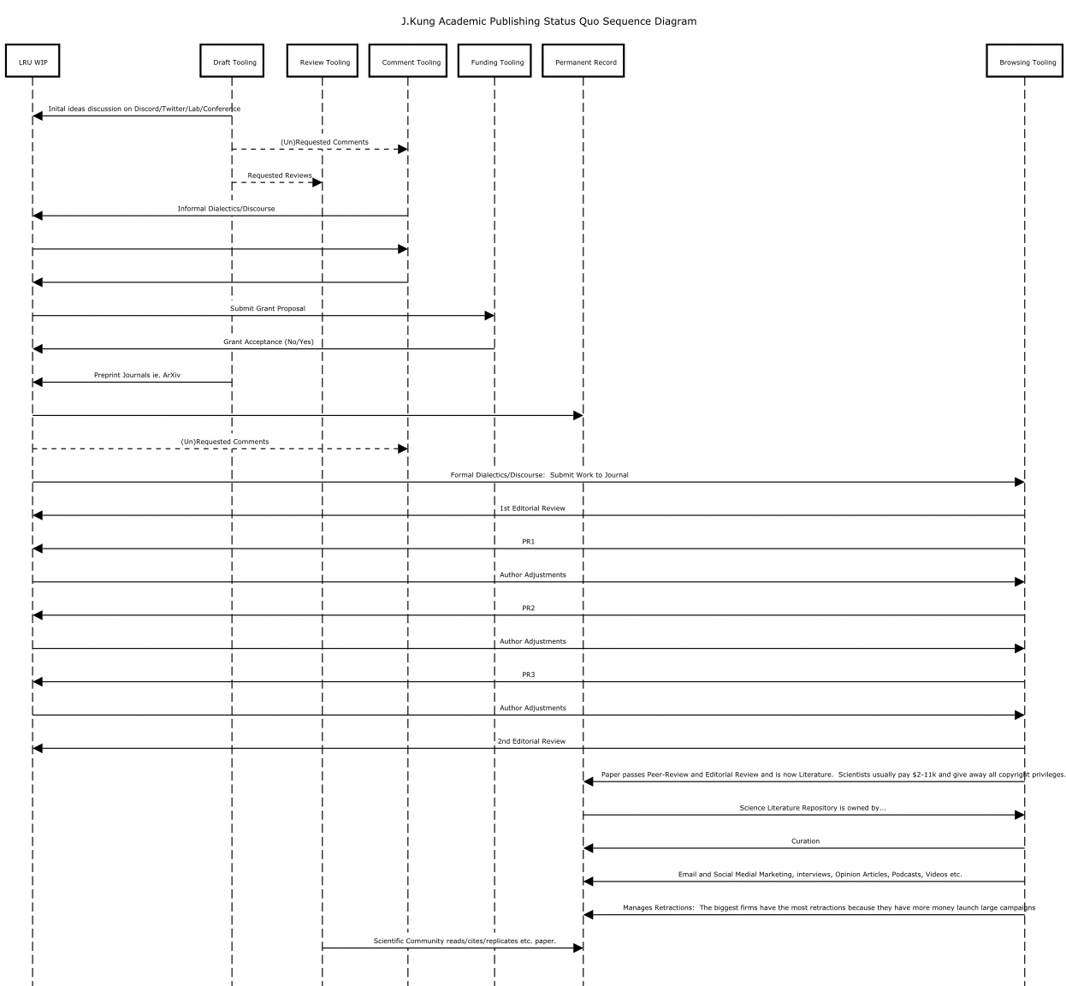

## Appendix B: Traditional vs. Decoupled Peer-Review Models

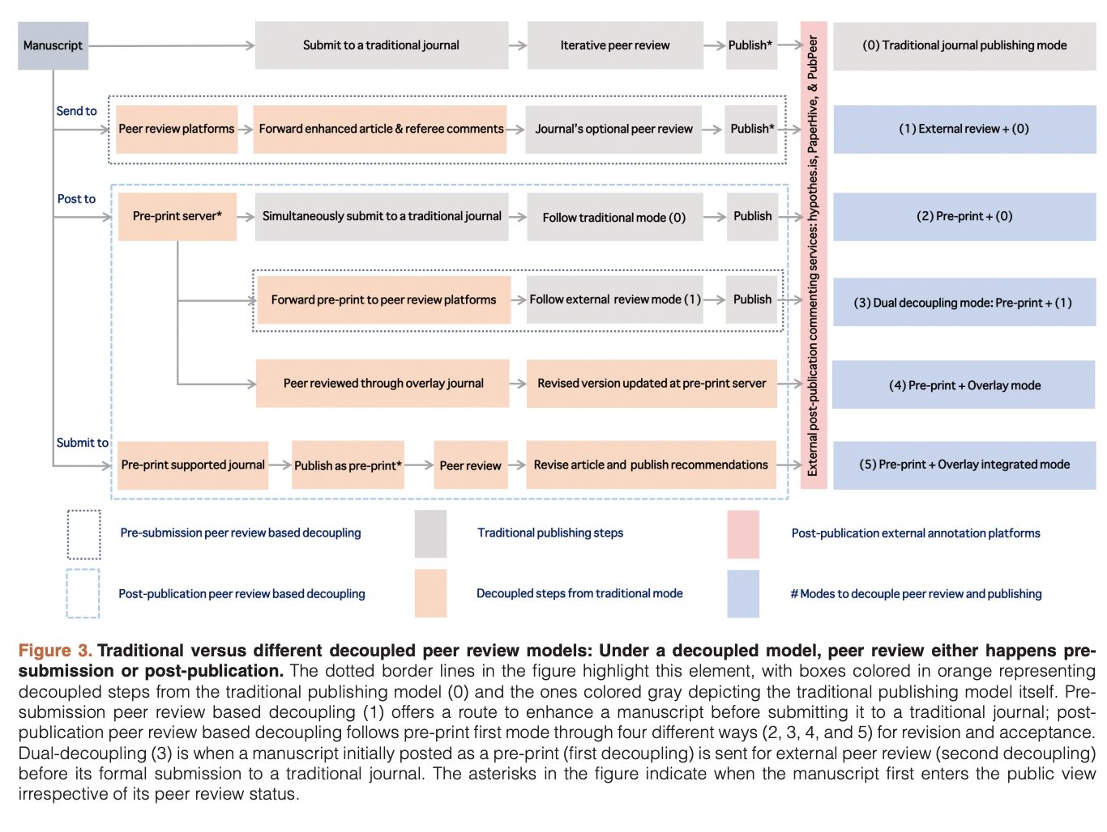[24]

## Appendix C: Shows how Government Funding has Shifted Priorities between 2000-2017

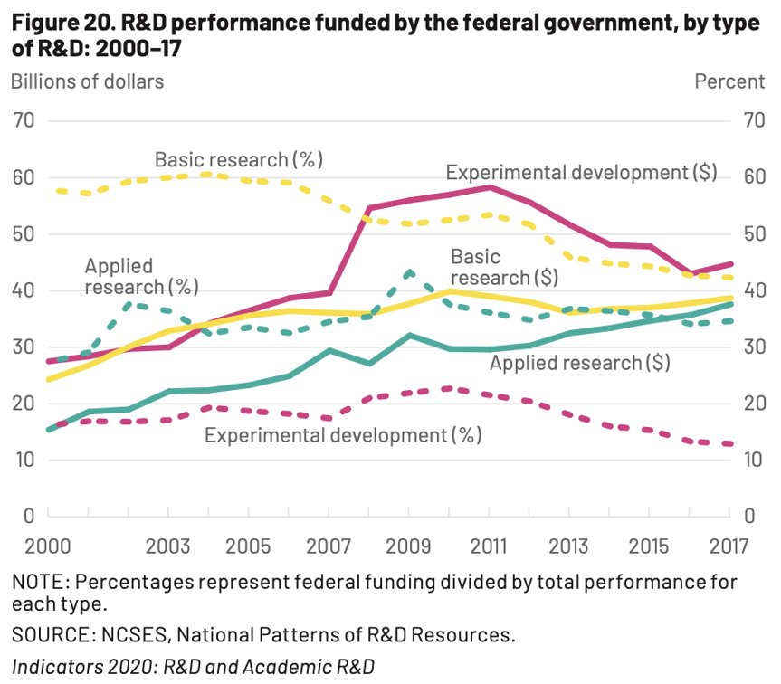

1. Vicious Cycle of Crises: The affordability crisis refers to the fact that Big Publishing are oligopolies. In their respective markets, they own an overwhelming majority of the academic paper copyrights and make up to 40+% profit margins. For context, the New York Times only makes ~8%. This makes it difficult for institutions to combat the functionality crisis – updating infrastructure for data discoverability etc. The functionality crisis in turn exacerbates the replicability crisis.
2. Eternal Review: A form of peer-review that uses a citation system to contextualize research, track its influences, and keep it alive for formal reuse, reappraisal, and revision for all time. This improves upon the current review system, which uses peer-review to publish.
3. Brembs, Bjorn. “Replacing Academic Journals” <https://doi.org/10.5281/zenodo.5564003> 9/2021>
4. The Cost of Knowledge: See Wikipedia < <https://en.wikipedia.org/wiki/The_Cost_of_Knowledge>> and the organization’s website <<http://thecostofknowledge.com/>>.
5. Science was always meant to be decentralized and distributed. Internet business models that now manage the knowledge distribution channels have degraded the integrity of science.
6. “Open Science,” Wikipedia < <https://en.wikipedia.org/wiki/Open_science>>
7. Open Research Europe: <<https://open-research-europe.ec.europa.eu/>>
8. Sci-Hub works in concert with LibGen, another pirating site. Given the users inputs – DOI, text input, URL of scholarly article – Sci-Hub will search LibGen for a copy. If a copy is found the material is delivered to the user, if it is not found, Sci-Hub will use its many automated techniques to bypass institutional access control barriers – i.e.. uses donated log-in information from scientists around the world – to deliver the material to the user and append a copy to LibGen.
9. H-index: Originally meant to be a stopgap measure as a moderate improvement on using just “**citation count**” as the main metric for research quality. H-index is calculated by the number of publications with a citation number greater than or equal to “h” – ie. 15 published papers with on average 15 citations/paper gets an h-index of 15.
10. IF: Originally created by librarians to prioritize journal subscriptions. Now IF is a major metric used by universities and funding agencies to judge the quality of a researcher. However, if Publishers mainly play a marketing function, the more people that see the paper, the more it is cited. This means that Publishers control the reputation infrastructure/prestige economy of Academic Science.
11. P-Hacking: p-values are a statistical validation method to make a statistical claim. A p-value of 0.85 means that there is a 15% chance that the null hypothesis is true or conversely that there is an 85% chance that the hypothesis/claim is true. Different fields have different p-value standards for publication. Researchers can design experiments to collect data in a way that high p-values can be higher and or omit/include data collected that will help make a claim for publishing an interesting story rather than discovering something interesting.
12. Springer Nature’s editorial criteria and processes page: <https://www.nature.com/nature/for-authors/editorial-criteria-and-processes>
13. Minimum Viable Protocol Requirement (MVPR) for a sustainable Decentralized Autonomous Organization (DAO). (Kaal, Calcaterra).
14. Agora <https://www.britannica.com/topic/agora>: The agora refers to the marketplace of Ancient Greek cities, which was a meeting place and a frequent site for philosophers and philosophical discourse. The concept is often evoked in academic circles.
15. Addressing Goodhart’s Law where “When a measure becomes a target, it ceases to be a good measure.”
16. Calcaterra, C., 2018. On-chain governance of decentralized autonomous organizations: Blockchain organization using Semada. *Available at SSRN 3188374*. Section 4.1: Page 36.
17. Subject to change with Founders Sprint findings.
18. Say there is a 100x increase in publication volume. Peer-review requirements of negative results, minor-positive results, and single observation studies will be much more lightweight, since many of these studies are being replicated anyway without community knowledge. This will require a more sophisticated database search engine that is currently available (see Technology Development section).
19. Also part of the “External Strategy.” This project will be a collaboration with Robert Carbone.
20. Forgetting is also in important part of human learning, however humans are already good enough at this and will not need “forget” functionality.
21. Narayanan, Arvind. “The concept of cryptocurrencies is built from forgotten ideas in research literature.” DOI:10.1145/3132259
22. Perez-Pena, R. (2013) <https://www.nytimes.com/2013/11/21/education/patenting-their-discoveries-does-not-pay-off-for-most-universities-a-study-says.html>
23. Paul Blackmore & Camille B. Kandiko (2011) Motivation in academic life: a prestige economy, Research in Post-Compulsory Education, 16:4, 399-411, DOI: [10.1080/13596748.2011.626971](https://doi.org/10.1080/13596748.2011.626971)
24. Tennant JP, Dugan JM, Graziotin D et al. A multi-disciplinary perspective on emergent and future innovations in peer review [version 1; peer review: 2 approved with reservations] F1000Research 2017, 6:1151 https://doi.org/10.12688/f1000research.12037.1